Photograph and Videos: The following pictures in figure 1 & 2 showed the evidences captured during the JIV (see pictures below).
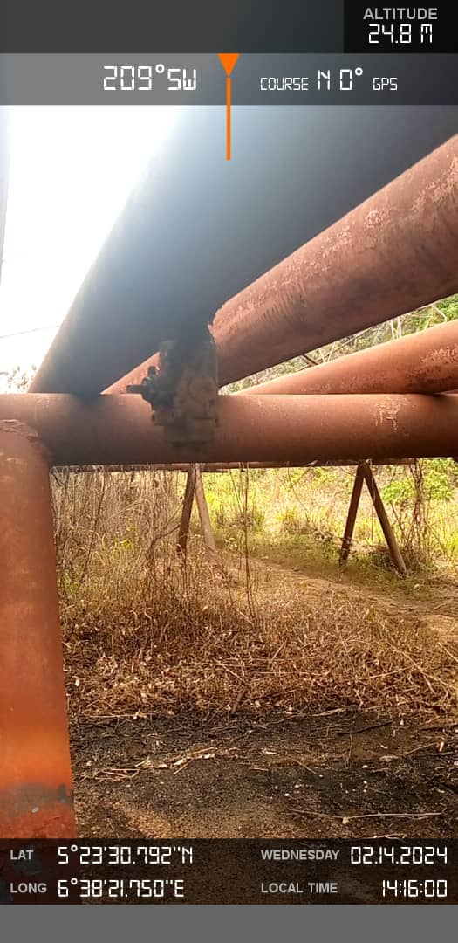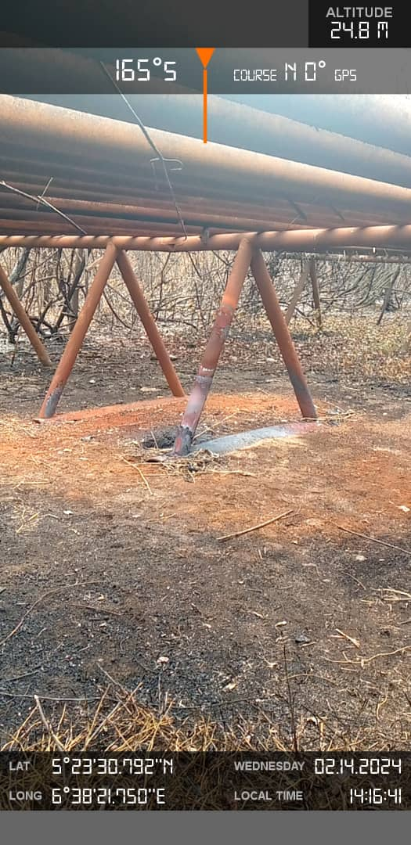
Figure 1. Arrow indicates Spill point Fig.2 Arrow showing less Impact
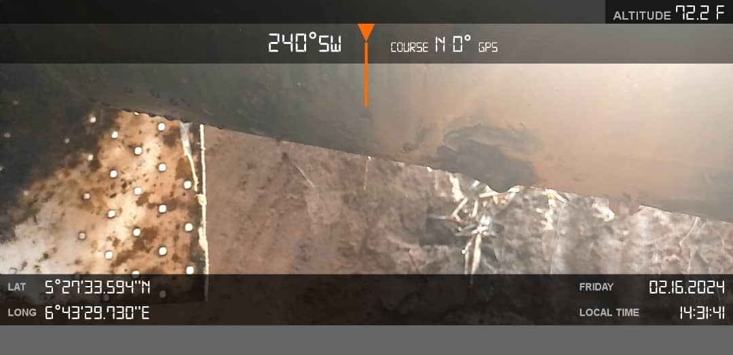 Figure 3 showing Repairs done

